**A**

**PROJECT REPORT**

**ON**

**“LOGIN AND REGISTRATION SYSTEM"**

SUBMITTED BY:

**Miss. Shelke Prachi Suhas (2124UCEF1002)**

SUBJECT:

**CORE C++ PROGRAMMING**

Under the guidance of

**Miss. ISHWARI TIRSE.**



**Department of Computer Science and Engineering**

**Sanjivani Rural Education Society's**

**SANJIVANI UNIVERSITY**

**KOPARGAON-423603, DIST: AHMEDNAGAR**

**2024-2025**

**INDEX**

|  |  |  |
| --- | --- | --- |
| **SR.**  **NO** | **CONTENT** | **PAGE NO.** |
| **1.** | **INTRODUCTION** | **3** |
| **2.** | **CODE** | **4** |
| **3.** | **OUTPUT** | **7** |
| **4.** | **CONCLUSION** | **9** |

**INTRODUCTION**

In today’s digital time, user authentication is a fundamental aspect of software development. A login and registration system serves as the gateway for users to securely access applications and services. This project demonstrates and services. The project demonstrates a simple implementation of such a system using C++. The system allows users to register by creating a unique username and password, and to log in by providing these credentials.

To develop an application for the Login and Registration System C++ is popular and right choice due to its user-friendly type, object-oriented design, and large community of developers. C++ provides easy and scalable platform for building an application.

There are many benefits of a C++ based Login and Registration System, i.e. User Authentication, Data Security, User Registration.

**CODE**

#include<iostream>

#include <fstream>

#include <string>

using namespace std;

void registerUser() {

string username, password;

cout << "Register\n";

cout << "Username: ";

cin >> username;

cout << "Password: ";

cin >> password;

ofstream outFile("users.txt", ios::app);

outFile << username << " " << password << endl;

outFile.close();

cout << "Registration successful!\n";

}

bool loginUser() {

string username, password, fileUsername, filePassword;

cout << "Login\n";

cout << "Username: ";

cin >> username;

cout << "Password: ";

cin >> password;

ifstream inFile("users.txt");

while (inFile >> fileUsername >> filePassword) {

if (fileUsername == username && filePassword == password) {

inFile.close();

return true;

}

}

inFile.close();

return false;

}

int main() {

int choice;

while (true) {

cout << "1. Register\n";

cout << "2. Login\n";

cout << "3. Exit\n";

cout << "Choose an option: ";

cin >> choice;

switch (choice) {

case 1:

registerUser();

break;

case 2:

if (loginUser()) {

cout << "Login successful!\n";

} else {

cout << "Invalid username or password!\n";

}

break;

case 3:

return 0;

default:

cout << "Invalid choice, try again.\n";

}

}

return 0;

}

**OUTPUT**

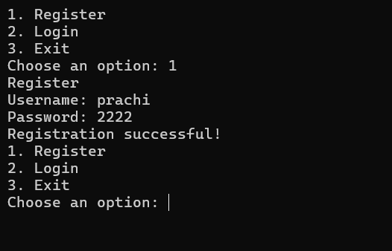

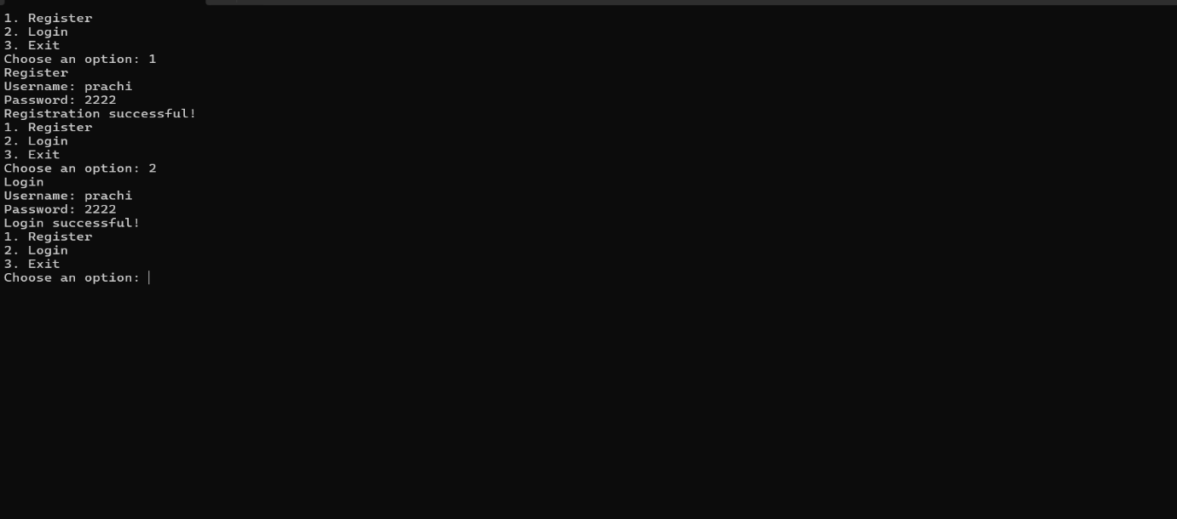

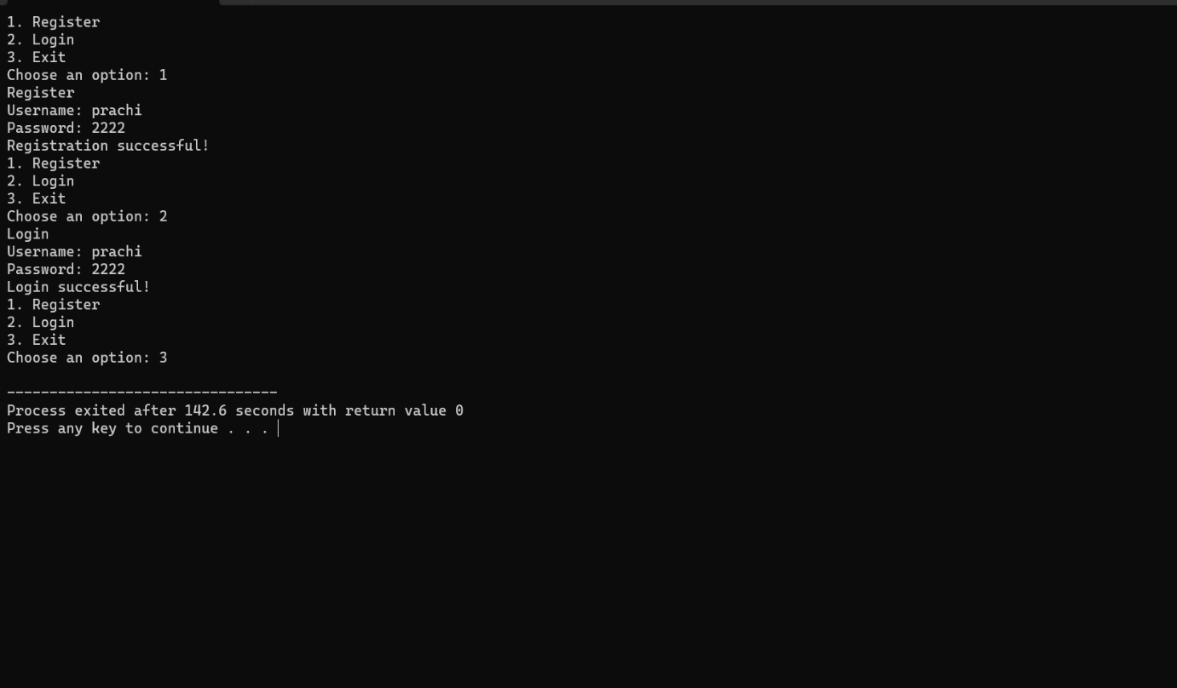

**CONCLUSION**

The Login and Registration System developed in this project by using concepts of C++ programming, including file handling, user input, and successfully registration. This basic implementation provides a foundation for understanding how user authentication can be managed in applications. This project serves as a stepping stone toward more complex applications and highlights the importance of secure practices in software development. It demonstrates the skills in web development but also discuss the importance of the security and user experience in software applications.